WEATHER DATA ANALYSIS

Problem Statement
Weather datasets contain information such as temperature, humidity, rainfall and wind speed. Manual analysis of weather observations makes it difficult to identify seasonal patterns, monthly trends and abnormal values. An interactive Power BI dashboard is required to transform raw weather data into meaningful insights for weather monitoring and analysis.

Objective
To create an interactive Power BI dashboard that provides insights into weather conditions, seasonal analysis, monthly trends and key weather indicators while enabling users to monitor weather patterns through interactive visualizations.

Purpose / Client Requirements
- Monitor Average Temperature, Average Humidity, Average Rainfall and Average Wind Speed.
- Analyze monthly wind speed trends.
- Compare average temperature across seasons.
- Analyze monthly rainfall trends.
- Monitor monthly humidity patterns.
- Provide interactive filtering using Year, Month and Season slicers.
- Display weather summary through a formatted table.

Dashboard

1. Average Temperature (Card)
Steps to Create: Select Card visual and add Temperature using Average aggregation.
How to Use: Displays the overall average temperature.
Information Provided: Average Temperature.

2. Average Humidity (Card)
Steps to Create: Card visual with Humidity (Average).
How to Use: Shows overall humidity.
Information Provided: Average Humidity.

3. Average Rainfall (Card)
Steps to Create: Card visual with Rainfall (Average).
How to Use: Displays average rainfall.
Information Provided: Average Rainfall.

4. Average Wind Speed (Card)
Steps to Create: Card visual with WindSpeed (Average).
How to Use: Displays average wind speed.
Information Provided: Average Wind Speed.

5. Monthly Wind Speed Trend (Line Chart)
Steps to Create: Axis = Month, Values = Average WindSpeed.
How to Use: Monitors monthly windspeed trend.
Information Provided: Peak and lowest windspeed months.

6. Average Temperature by Season (Column Chart)
Steps to Create: Axis = Season, Values = Average Temperature.
How to Use: Compares seasonal temperatures.
Information Provided: Hottest and coolest season.

7. Monthly Average Rainfall (Column Chart)
Steps to Create: Axis = Year & Month, Values = Average Rainfall.
How to Use: Compares rainfall over time.
Information Provided: Wettest and driest periods.

8. Average Humidity by Month (Line Chart)
Steps to Create: Axis = Year & Month, Values = Average Humidity.
How to Use: Displays humidity trend.
Information Provided: Monthly humidity pattern.

9. Slicers

Steps to Create: Create Slicer visuals, Add Year to the first slicer, Month to the second slicer And Season to the third slicer.

How to Use:Allows users to interactively filter all dashboard visuals based on the selected Year, Month, or Season.

Information Provided: Year, Month, Season wise Weather Analysis And Interactive Dashboard Filtering

10. Summary Table

Steps to Create: Select the Table visual. Add Month And Add Temperature,Humidity,Rainfall,WindSpeed using Averages. Apply Conditional Formatting to Temperature, Humidity, Rainfall, and Wind Speed columns.

How to Use: Displays monthly weather statistics in a tabular format, allowing users to compare weather conditions across different months.

Information Provided: Monthly Average For Temperature,Humidity,Rainfall,WindSpeed And Month Wise Weather Comparison

11. Drill Through Summary Table

Steps to Create: Create a new report page. Add Season to the Drill Through field. Insert a Table visual. Add Month, Season, Average Temperature, Average Humidity, Average Rainfall, and Average Wind Speed. Apply Conditional Formatting to the weather metrics.

How to Use: Right click on a Season from Season chart and select Drill Through to Season Summary to view detailed weather information for the selected season.

Information Provided: Provide Detailed Weather Summary for the Selected Season with Average Temperature, Average Humidity, Average Rainfall, Average WindSpeed

Solved Problems
- Cleaned the weather dataset.
- Removed duplicate records.
- Handled missing values.
- Detected and removed outliers using the IQR method.
- Created Month, Year, Season and Rolling Average features.
- Analyzed monthly and seasonal weather trends.
- Built an interactive Power BI dashboard.
- Implemented Year, Month and Season slicers.

Conclusion
The Weather Data Analysis Dashboard transforms raw weather observations into meaningful insights. It enables users to monitor temperature, humidity, rainfall and wind speed through KPI cards, trend charts, seasonal comparisons and interactive filters. The dashboard supports quick understanding of weather patterns and data-driven analysis.

Dashboard Photo
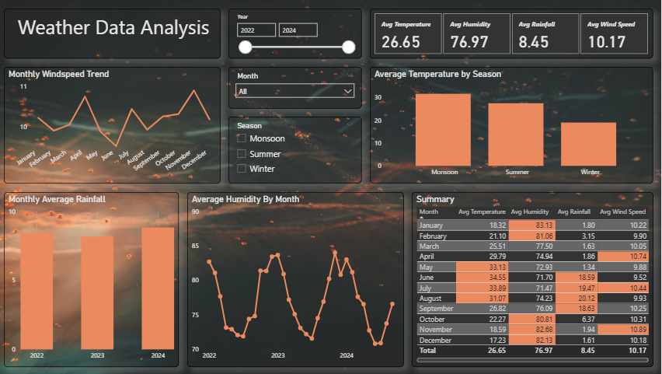
Drill Through
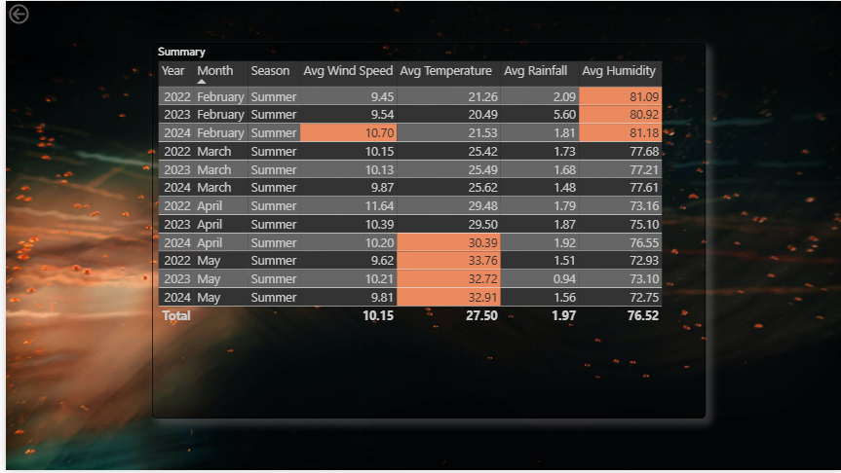

Name: Jayesh Rajendra Ingale

